20.27: The final temperature will be

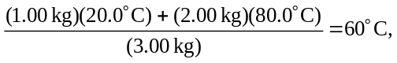

and so the entropy change is
